Deforestation patterns.

1. Fish-bone.

Deforestation due to build or paved roads that generate side roads used by loggers or miners to reach their quarries, consequently this side roads spawn smaller ones creating the deforestation pattern of a “fish bone” (Figure 1). 95% of deforestation in Brazil Amazon has taken place within five and a half kilometers of a road or one kilometer of a navigable river. (F. Seymour, J. Busch. Why Forest, Why now, 2016)

Figure 1, Source: World Resources Institute, "Global Forest Watch"

1. Radial.

Radial (or pie) patterns of land use is typical of new settlements or resettlement schemes and large agricultural development. For example, San Javier in the Santa Cruz Department of Bolivia, where tropical forest was cleared in the mid- 80’s to resettle people from the Altiplano in the context of the Tierra Baja project. At the center of each unit is a small community including a church, bar/café, school and soccer field (essentials of life in rural Bolivia)

Figure , Source: Earth Observatory, Deforestation in Bolivia

1. Dendritic

Related to deforestation caused by miners and loggers that pushed into undeveloped parts of the forest, building roads that generally followed the natural contours of the land and formed curving, dendritic shapes.

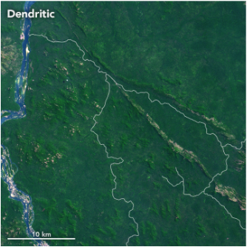

Figure , Source: Earth Observatory, Making Sense of Amazon Deforestation Patterns

1. Rectangular

This pattern of deforestation tends to leave large rectangular clearings that reflect careful surveying by large-scale cattle-ranching operations. In Paraguay deforestation has been widespread in the last years. From 1987 to 2012 Paraguay has lost near 44,000 square kilometers (17,000 square miles), mainly because of the expansion of cattle farms in the western part of the country.

Figure , Source: Earth Observatory, Deforestation in Paraguay